Employee ID: 11949
Employee Name: Muthuraj Periyasamy

Date:12-01-2023

- Use your previous [ Angular, Spring Boot & Microservices ] lab assessment [dated 19-Dec-2023] project / application to write the following test cases.
3.Functional Testing (Automated Testing): [ 2 Hours ]
- Write the Automated Test cases by using Selenium for your application. And generate the test report using TestNG.
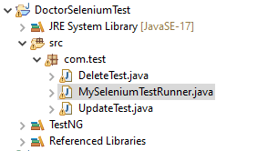
1.MySeleniumTestRunner - InsertedClass:
package com.test;
import org.openqa.selenium.By;
import org.openqa.selenium.WebDriver;
import org.openqa.selenium.WebElement;
import org.openqa.selenium.chrome.ChromeDriver;
import org.testng.annotations.AfterClass;
import org.testng.annotations.BeforeClass;
import org.testng.annotations.BeforeTest;
import org.testng.annotations.Test;
public class MySeleniumTestRunner {
private WebDriver driver;

@BeforeTest
public void initializer() {
System.setProperty("webdriver.Chrome.driver", "driver/Chromedriver.exe");
driver = new ChromeDriver();
}
@Test
public void site() {
driver.navigate().to("http://localhost:4200/");
}
@Test
public void testdoctorFormSubmission() {
WebElement doctorIdField = driver.findElement(By.name("id"));
doctorIdField.sendKeys("3");
WebElement doctorNameField = driver.findElement(By.name("name"));
doctorNameField.sendKeys("Karthik");

WebElement doctorAgeField = driver.findElement(By.name("age"));
doctorNameField.sendKeys("40");

WebElement doctorEmailField = driver.findElement(By.name("email"));
doctorEmailField.sendKeys("karthik@example.com");
WebElement doctorSpecializationField = driver.findElement(By.name("spl"));
doctorSpecializationField.sendKeys("orthopedics");
WebElement doctorPhnoField = driver.findElement(By.name("phn"));
doctorPhnoField.sendKeys("78965354");

WebElement doctorLocationField = driver.findElement(By.name("loc"));
doctorLocationField.sendKeys("Chennai");

WebElement insertButton = driver.findElement(By.xpath("//button[@value='Insert']"));
insertButton.click();
}
}

1.Automated Inserted:
Before
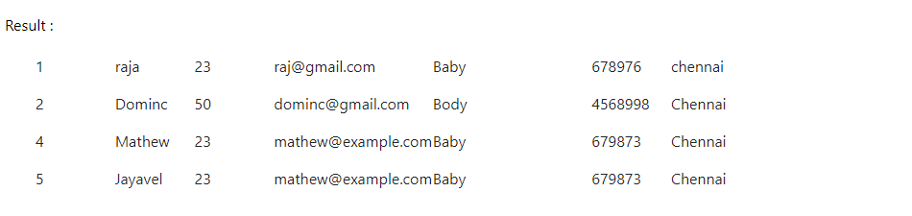
After 3 ID Automated Inserted:
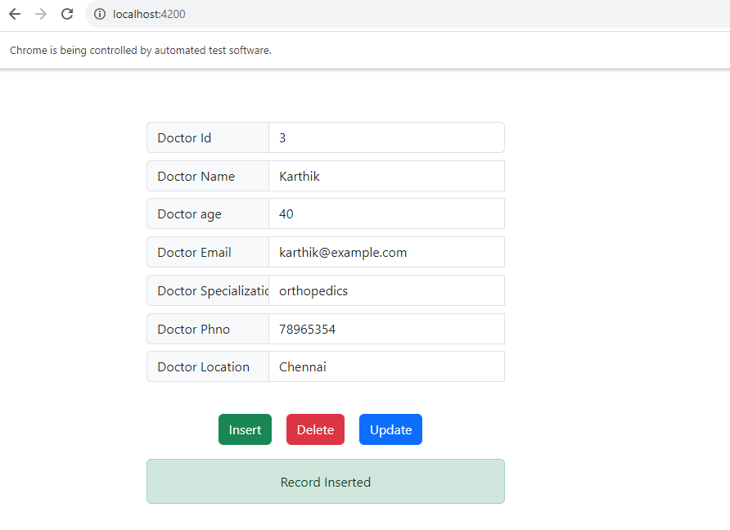
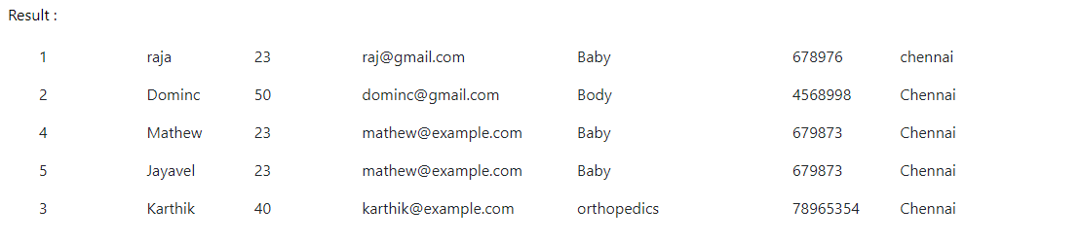

2.UPDATED :

package com.test;
import org.openqa.selenium.By;
import org.openqa.selenium.WebDriver;
import org.openqa.selenium.WebElement;
import org.openqa.selenium.chrome.ChromeDriver;
import org.testng.annotations.AfterClass;
import org.testng.annotations.BeforeClass;
import org.testng.annotations.BeforeTest;
import org.testng.annotations.Test;
public class UpdateTest {
private WebDriver driver;

@BeforeTest
public void initializer() {
System.setProperty("webdriver.Chrome.driver", "driver/Chromedriver.exe");
driver = new ChromeDriver();
}

@Test
public void site() {
driver.navigate().to("http://localhost:4200/");
}
@Test
public void testdoctorFormSubmission() {

WebElement doctorIdField = driver.findElement(By.name("id"));
doctorIdField.sendKeys("3");

WebElement doctorNameField = driver.findElement(By.name("name"));
doctorNameField.sendKeys("Valan");

WebElement doctorAgeField = driver.findElement(By.name("age"));
doctorNameField.sendKeys("47");

WebElement doctorEmailField = driver.findElement(By.name("email"));
doctorEmailField.sendKeys("valan@example.com");

WebElement doctorSpecializationField = driver.findElement(By.name("spl"));
doctorSpecializationField.sendKeys("pathology");

WebElement doctorPhnoField = driver.findElement(By.name("phn"));
doctorPhnoField.sendKeys("9855734");

WebElement doctorLocationField = driver.findElement(By.name("loc"));
doctorLocationField.sendKeys("Kanyakumari");

WebElement updateButton = driver.findElement(By.xpath("//button[@value='Update']"));
updateButton.click();

}
}

Before:

After:After 3 ID Automated Updated:
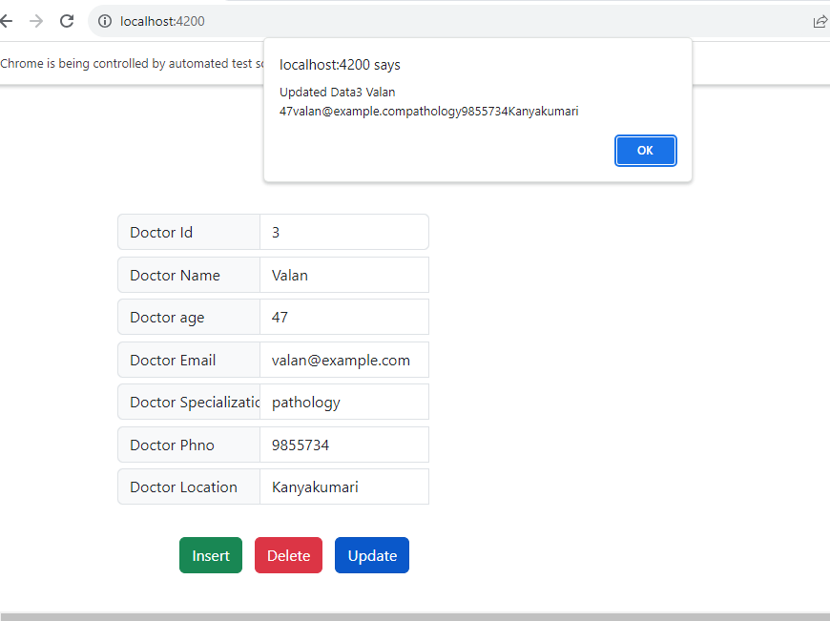
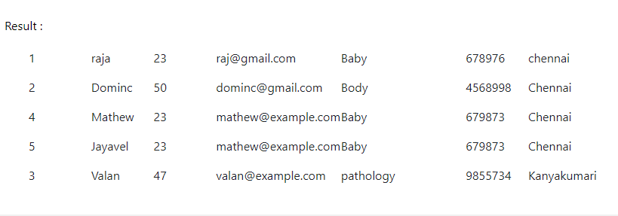

3.Delete
Before:

After 3 ID Automated Delete:
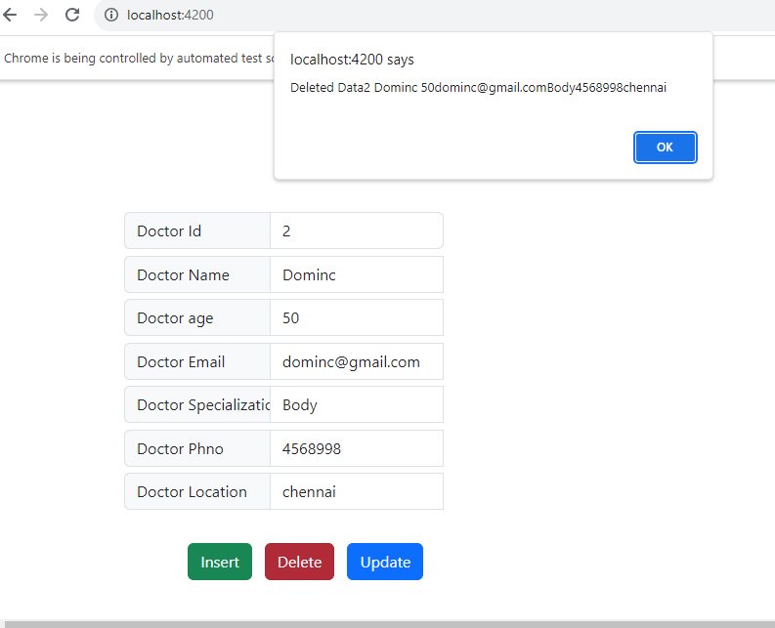
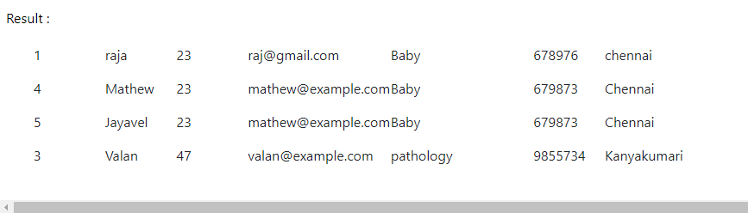
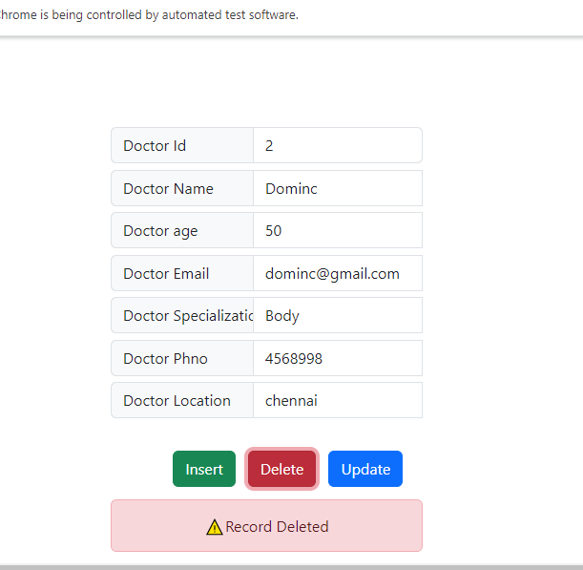

4.GET PARTICULAR Doctor ID automatically result displayed:
